1. Repository Setup and Initial Commit
   1. Create a new repository on GitHub*

- Go to [GitHub](https://github.com) and create a new repository

* 1. 2Clone the repository locally

c. Initialize Git and create the first commit

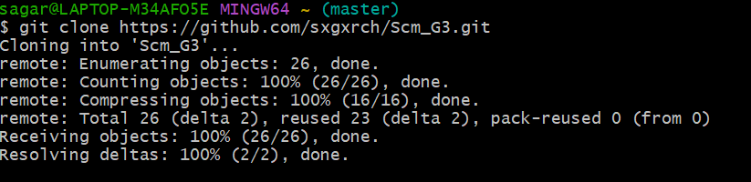

1. Branch Creation and Updates

Steps

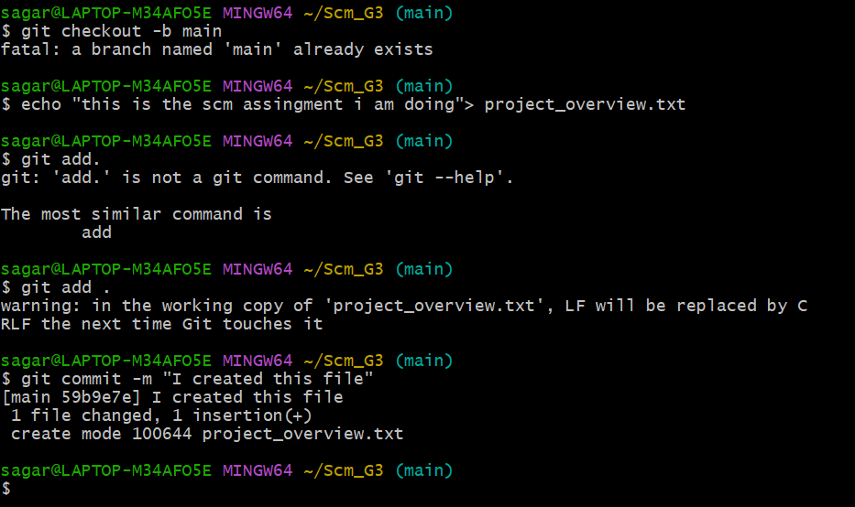

3. Merge and Conflict Resolution

Steps

1. Modify feature_details.txt in the main branch

2. Merge feature-update into main

git checkout main

git merge feature-update

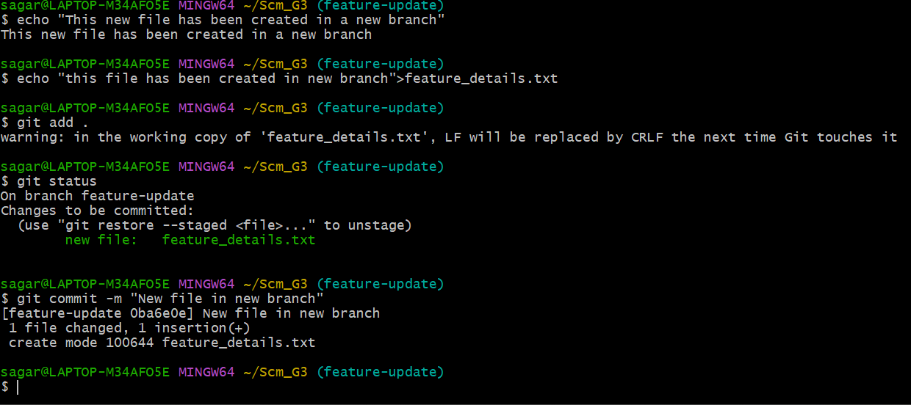

3. Resolve the conflict

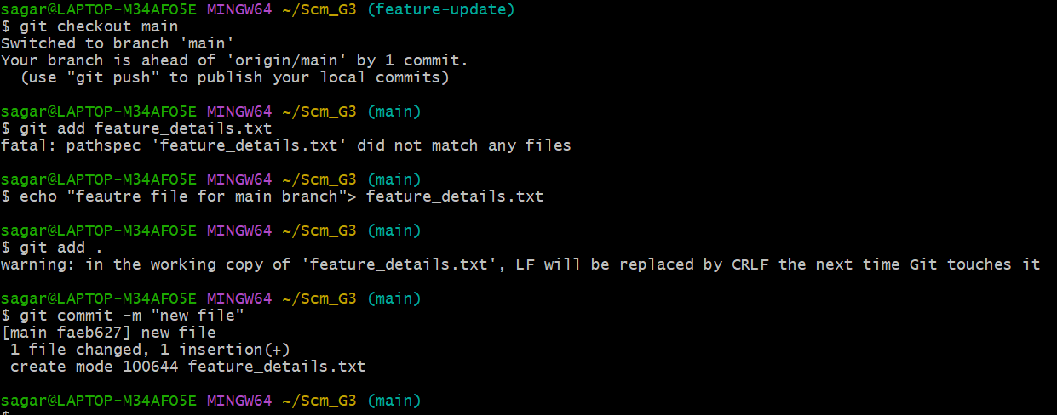

4. Stage, commit, and push the resolved changes

4. Repository Audit

Check Repository Status and History

